C:\Users\janeth\Pictures\8.PNGC:\Users\janeth\Pictures\7.PNG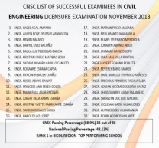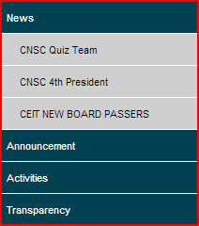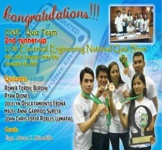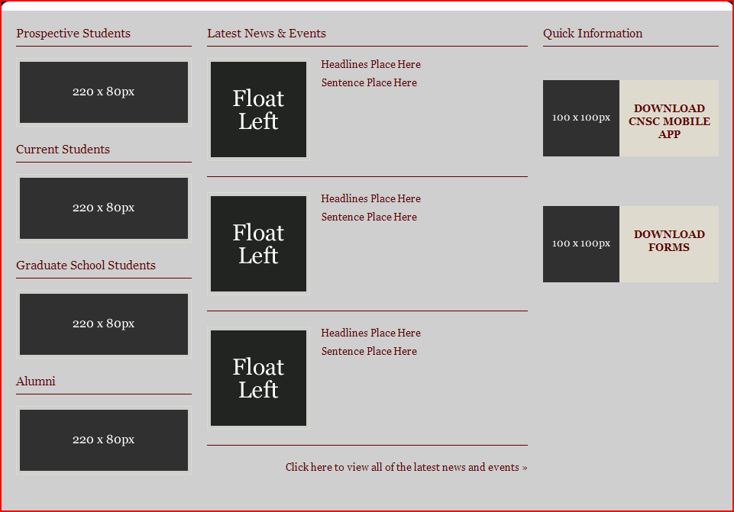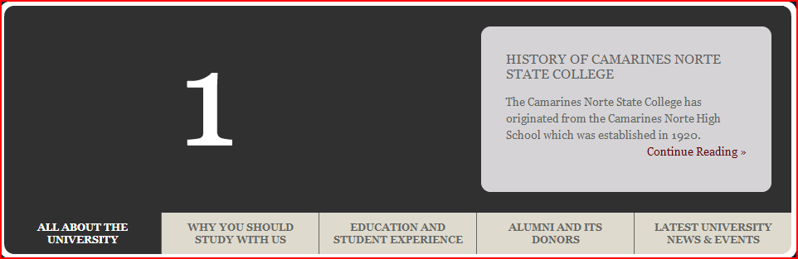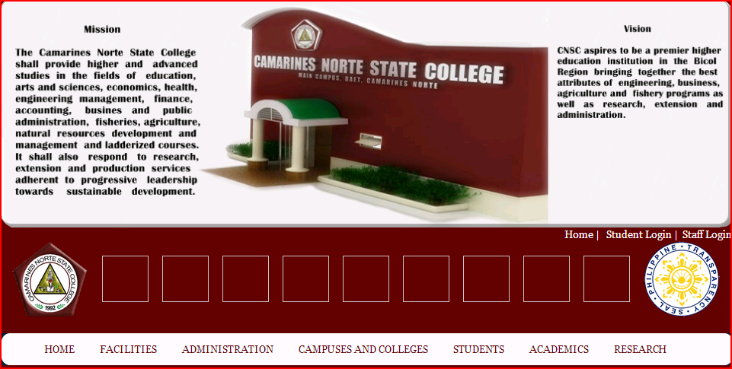HOMEPAGE

may link yan sa new page including information all about quiz team, etc

Slider images from cnsc

SEARCH

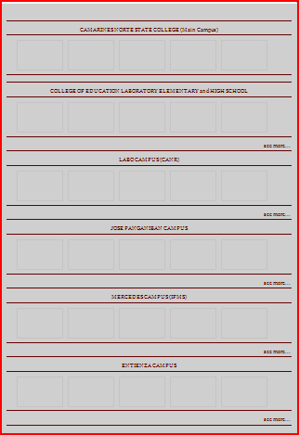

may link ang bawat name of campus sa new page including (main campus) > library, comp lab, comp demo rooms, instrumentation room, chem lab, biology lab, physics lab, food service mngt lab, residence hall and information all about the facilities of other campuses

Facilities



